PROJECT DOCUMENTATION

- Title :- Customer Churn Analysis – Feature Engineering .

Submitted By :- Sujal Sudhakar Salvi .
Course :- Data Analytics .
Submitted To :- Prajakta Tayde .

- Introduction :-
Customer churn means when customers stop using a company’s service. Understanding customer churn is important because it helps businesses improve customer retention. In this project, a customer churn dataset is analyzed and prepared using Python . The main goal of this notebook is to clean the data and create useful features that explain customer behavior in a simple and clear way. This project is written in an easy-to-understand format and focuses on practical data analysis skills . The main aim of this project is to transform raw customer data into meaningful and structured features that clearly represent customer behavior , spending patterns, and loyalty. This notebook is designed to be simple, well-documented, and easy to understand, making it suitable for learning purposes as well as for showcasing practical data analysis skills.

- Objectives :-
  - To understand the structure and content of the customer churn dataset .
  - To clean the data by handling missing values and incorrect data types .
  - To perform feature engineering to create meaningful customer behavior features .
  - To visualize important patterns using simple plots .
  - To prepare a clean and well-structured dataset for further analysis or modelling .

- Dataset Description :-
Dataset Name :- Customer Churn Dataset .
Description :- This dataset contains customer information such as services used, tenure, billing details, and churn status. Each record represents one customer and is used to analyze customer behavior and understand reasons for customer churn.

- Column Description :-

- CustomerID :-A unique identification number assigned to each customer. It helps differentiate one customer record from another.

- Gender :- Indicates the gender of the customer, such as male or female.

- SeniorCitizen :-Shows whether the customer is a senior citizen. It is usually represented as 1 for yes and 0 for no.

- Partner :-Indicates whether the customer has a partner or not.

- Dependents :-Shows whether the customer has dependents who rely on them.

- Tenure :- Represents the number of months the customer has been using the company’s services.
- PhoneService :- Indicates whether the customer has subscribed to phone service.

- MultipleLines :- Shows whether the customer has more than one phone line.

- InternetService :- Describes the type of internet service used by the customer, such as DSL, Fiber optic, or no internet service.

- OnlineSecurity :- Indicates whether the customer has online security service.

- OnlineBackup :- Shows whether the customer uses online backup services.

- DeviceProtection :- Indicates if the customer has device protection coverage.

- TechSupport :- Shows whether the customer has access to technical support services.

- StreamingTV :- Indicates whether the customer subscribes to streaming TV services.

- StreamingMovies :- Shows whether the customer subscribes to streaming movie services.

- Contract :- Describes the type of contract the customer has, such as month-to-month or long-term contract.

- PaperlessBilling :- Indicates whether the customer uses paperless billing.

- PaymentMethod :- Shows the method used by the customer to make payments, such as credit card or electronic check.

- MonthlyCharges :- The amount charged to the customer every month for the services used.

- TotalCharges :- The total amount charged to the customer over the entire tenure period.

- Churn :- Indicates whether the customer has stopped using the service. It is the target variable for churn analysis.

- Dataset Analysis :-

- Converting TotalCharges Column to Numeric Format :-
Explanation :- In this step, the TotalCharges column is converted into a numeric data type so that mathematical operations can be performed on it. In the original dataset, this column may contain text values or blank spaces, which can cause errors during analysis. The pd.to_numeric() function is used to safely convert the column into numbers. The errors='coerce' parameter automatically converts any invalid or non-numeric values into missing values . This ensures that the dataset remains clean and ready for further processing, such as calculations, feature engineering, or model building.

- Handling Missing Values in TotalCharges Column :-
Explanation :- This step is used to handle missing values present in the TotalCharges column. After converting the column to numeric format, some values may become missing due to invalid or blank entries. To fix this, the missing values are replaced with the median value of the column. The median is chosen because it is not affected by very high or very low values and gives a more balanced replacement. Using inplace=True updates the original dataset directly without creating a new column. This step ensures that the dataset does not contain missing values and can be used smoothly for further analysis and feature engineering.

- Creating Average Monthly Spending Feature :-
Explanation :- In this step, a new feature called AvgMonthlySpend is created to calculate the average amount a customer spends per month. It is calculated by dividing the total charges by the customer’s tenure. One is added to the tenure value to avoid division by zero for new customers who have a tenure of zero. This feature helps normalize the total charges and provides a clearer understanding of customer spending behavior on a monthly basis, which is useful for analyzing and predicting customer churn.

- Creating Loyal Customer Indicator Feature :-
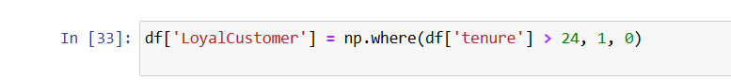
Explanation :- This step creates a new column called LoyalCustomer to identify long-term customers. If a customer has stayed with the company for more than 24 months, they are marked as 1, indicating a loyal customer. Customers with a tenure of 24 months or less are marked as 0. This feature helps separate long-term and short-term customers and makes it easier to analyze how customer loyalty affects churn behavior. It also converts this information into a numeric format that can be easily used in further analysis or machine learning models.

- One-Hot Encoding Using get_dummies :-
Explanation :- Categorical columns in the dataset are converted into numerical format using the get_dummies() function. Many machine learning models cannot work with text values such as Yes/No or service types, so these values are transformed into binary columns containing 0s and 1s.
The drop_first=True parameter removes one category from each encoded column to avoid duplicate information and reduce multicollinearity. After this step, the dataset becomes fully numeric and ready for further analysis or model building.

- Encoding Categorical Features After Removing Customer ID :-
Explanation :- The customerID column is removed because it is only an identifier and does not provide useful information for analysis or prediction. After dropping this column, categorical features are converted into numerical values using the get_dummies() function.
This process creates new binary columns (0 and 1) for each category, making the data suitable for machine learning algorithms. The drop_first=True option helps reduce redundancy by removing one category from each encoded feature, which improves model efficiency and avoids multicollinearity.

- Visualizing Distribution of Monthly Charges :-
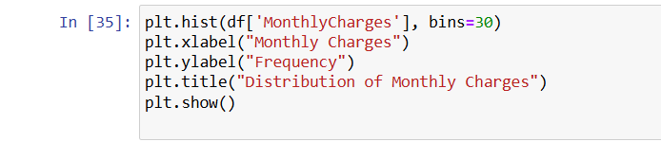
Explanation :- This code creates a histogram to show how monthly charges are distributed among customers. The data is divided into 30 bins, which helps group similar charge values together and makes the distribution easier to understand. The x-axis represents the monthly charges, while the y-axis shows how many customers fall into each charge range. This visualization helps identify common pricing ranges, understand spending patterns, and check for unusually high or low charges that may affect further analysis or modeling.

- Customer Churn Count Bar Chart :-
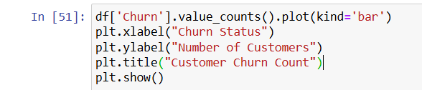
Explanation :- This bar chart shows the total number of customers based on their churn status. The x-axis represents whether a customer has churned or not, while the y-axis shows the number of customers in each category. Each bar clearly displays how many customers stayed with the company and how many decided to leave.From this graph, it is visible that the number of non-churned customers is higher than the number of churned customers. This indicates that most customers continue using the service, while a smaller portion stop their subscription. This visualization helps in understanding the overall churn distribution and highlights the importance of focusing on the churned group to improve customer retention strategies.

- Conclusion :-
In this project, the customer churn dataset was carefully cleaned and prepared using feature engineering techniques. Missing values and incorrect data types were handled to improve data quality. New features were created to better understand customer spending behavior and loyalty. Visualizations were used to analyze data distribution and patterns. Overall, these steps helped transform raw data into a structured and meaningful dataset that is ready for further analysis or churn prediction models.

